Title
(Authors)
Keywords:
- Introduction:
(This section provides the literature review to provide background of the report. It includes the reasons for writing the report, the objectives of the activity, and the definition of terms.

- Methodology:
(This describes the methods of answering why this activity was conducted. Methods may be characterized by using a framework, etc.. When data were used to answer questions in the activity, this may indicate why this type of data is appropriate, relevant, and necessary to answer the questions. It also explains the process of data collection)
- Results:
(This summarizes and presents the accomplished activity/ies and may present the findings. Results and conclusions may be presented in written text, tables, graphs, and other illustrations.)
Table 3.1. The numbering of tables is based on the chapter number, followed by the table number within the chapter. It is placed align left above the table itself.

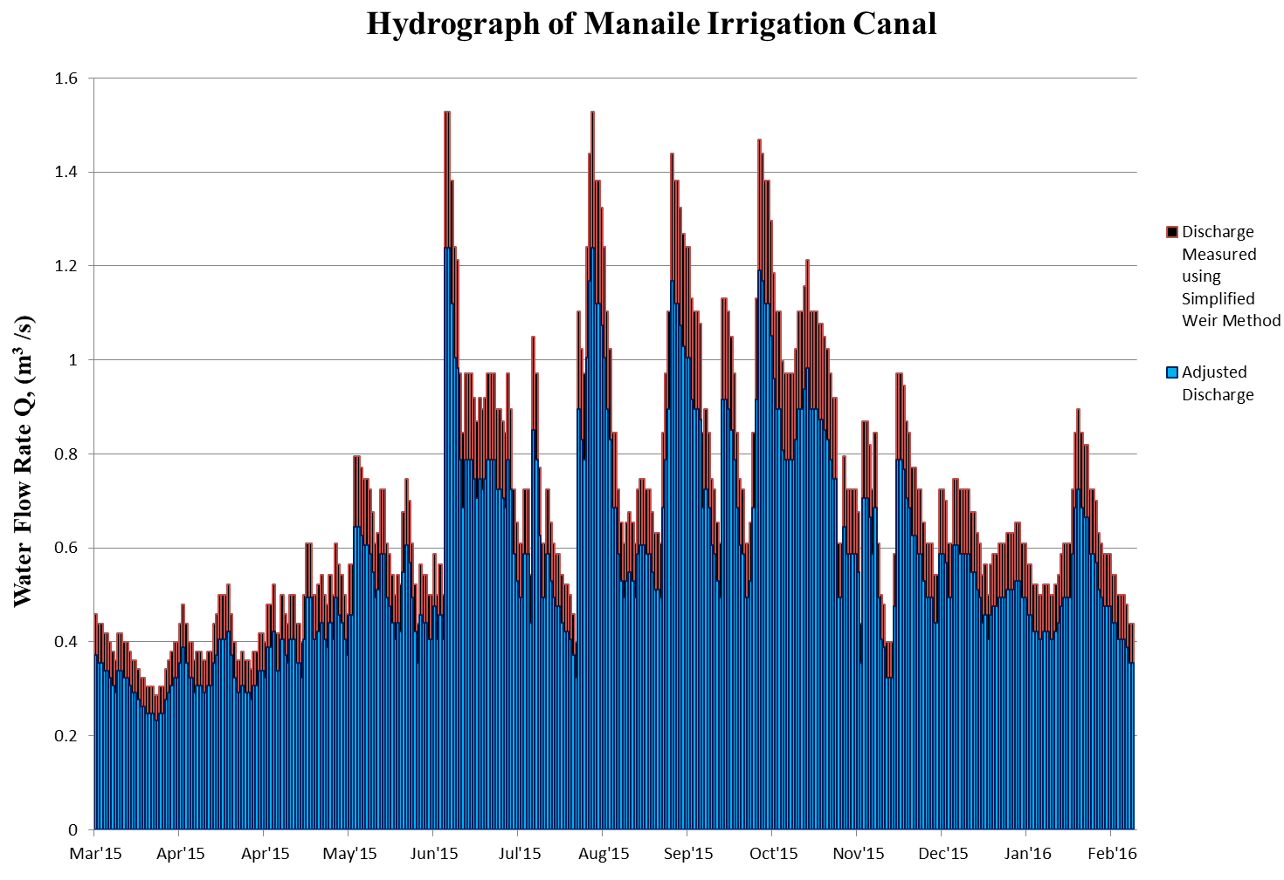
Fig. 3.1. The numbering of figures is based on the chapter number, followed by the figure number within the chapter. It is placed below and at the center of the figure.

Appendices:
(Provide a caption in each appendix attached. The numbering of the captions in the appendices will be in the same sequence as the figure's numberings. This contained the ff;
- Group picture; Training team picture; pictures during activities
- Approved request letter
- Travel order
- Certificates (participant’s participation, appreciation from client/partner, recognition for training team (resource person, facilitator, coordinator, secretariat)
- Attendance sheet
- Program
- IEC Materials
- Ebalwasyon ng Gawain (1 sample only)

References:

Acknowledgement:

